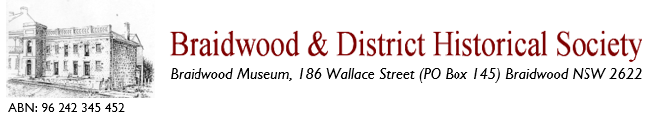
Tour Booking Form

Business Contact Details:
Company Name:

Business Address:

Contact Name: Phone:

Email:
Your Booking:
Preferred Tour Date: Time:

Number of guests:
Group Name:

Town Bus Tour (yes/no): Walking Tour (yes/no):
Museum Visit (yes/no):

Comments or Message:

Send this form to: Booking Coordinator at help@braidwoodmuseum.org.au
You will receive a confirmation email from our staff to confirm this booking.

All tours are delivered by trained volunteers. Proceeds support the Braidwood & District Historical Society and Museum.

Office administration only
Designated tour guide ------------------------------------------------------------------------------------------
Booked by--------------------------------------------------------------date ---------------------------------------
Confirmed by ---------------------------------------------------------date ---------------------------------------

